file 1: (max = 10.8715764659955 , min = 7.863488401836389)

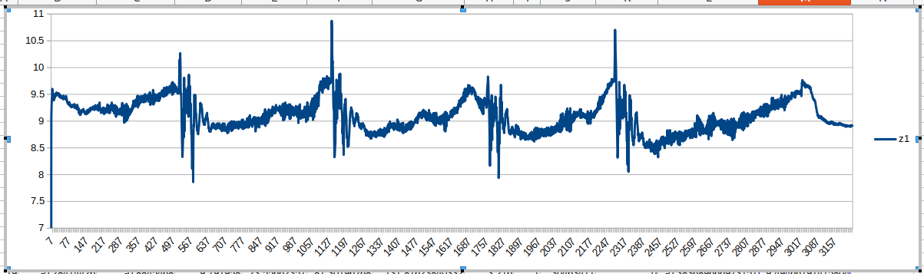
file 2: (max = 10.577086942259225 , min = 8.452870873070816)

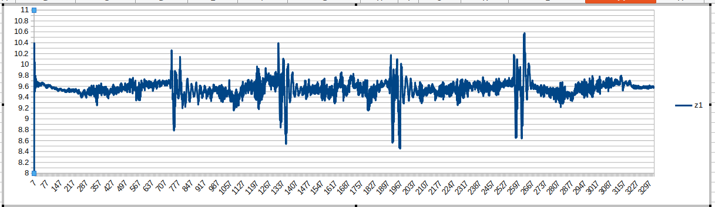
file 3: (max = 10.48706717426673 , min = 7.8879523641054154)

